**1.Jobby App Project**

In this project, let's build a Jobby App by applying the concepts we have learned till now.

Design Files

Login Route:

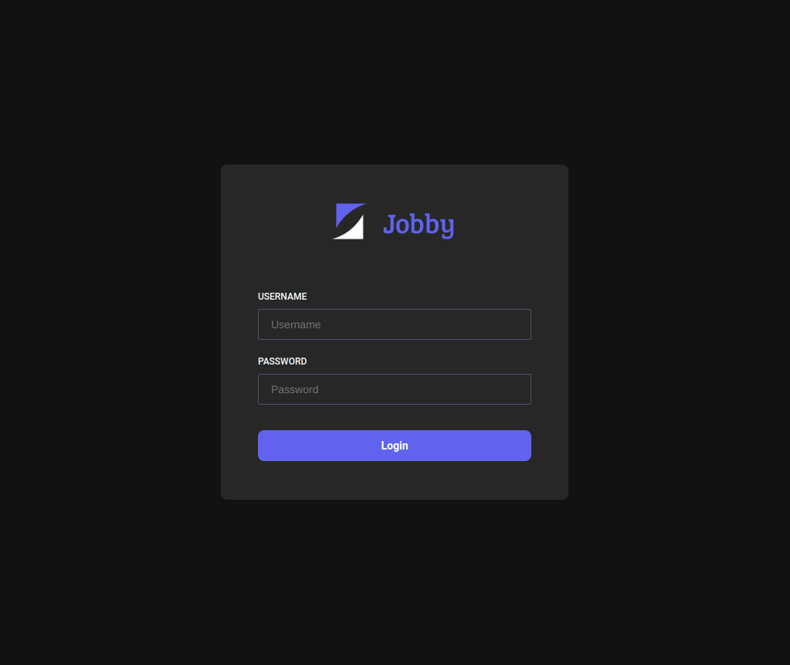

Home

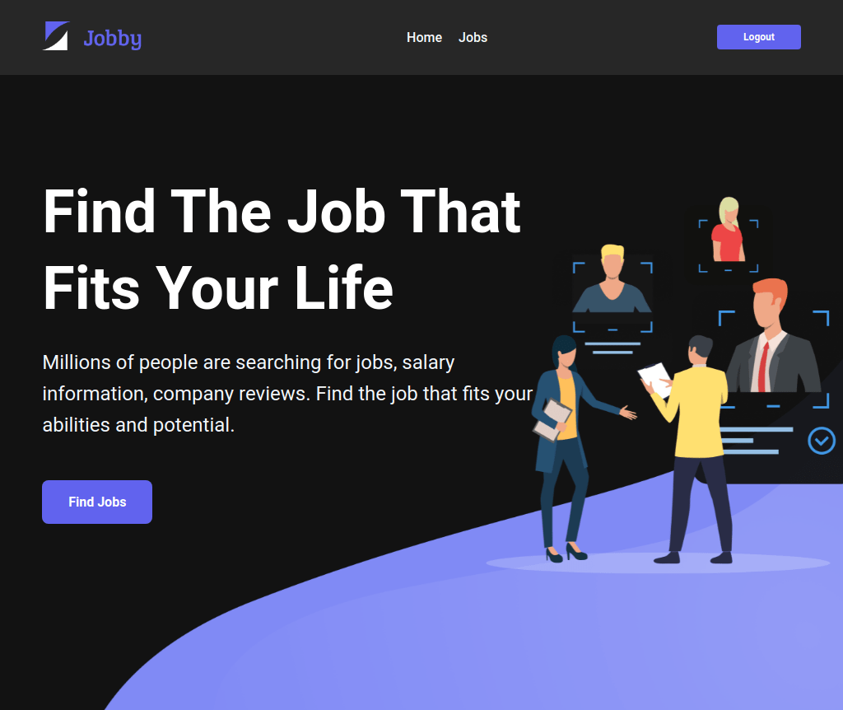

JOBS Success View :

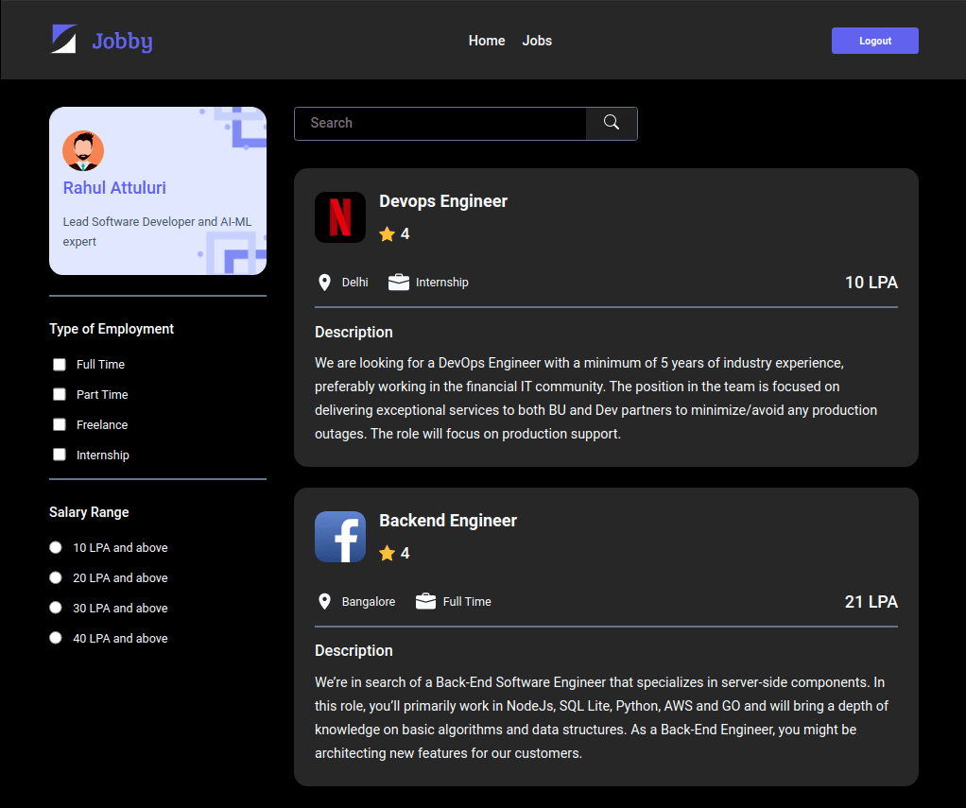

No Jobs Found :  
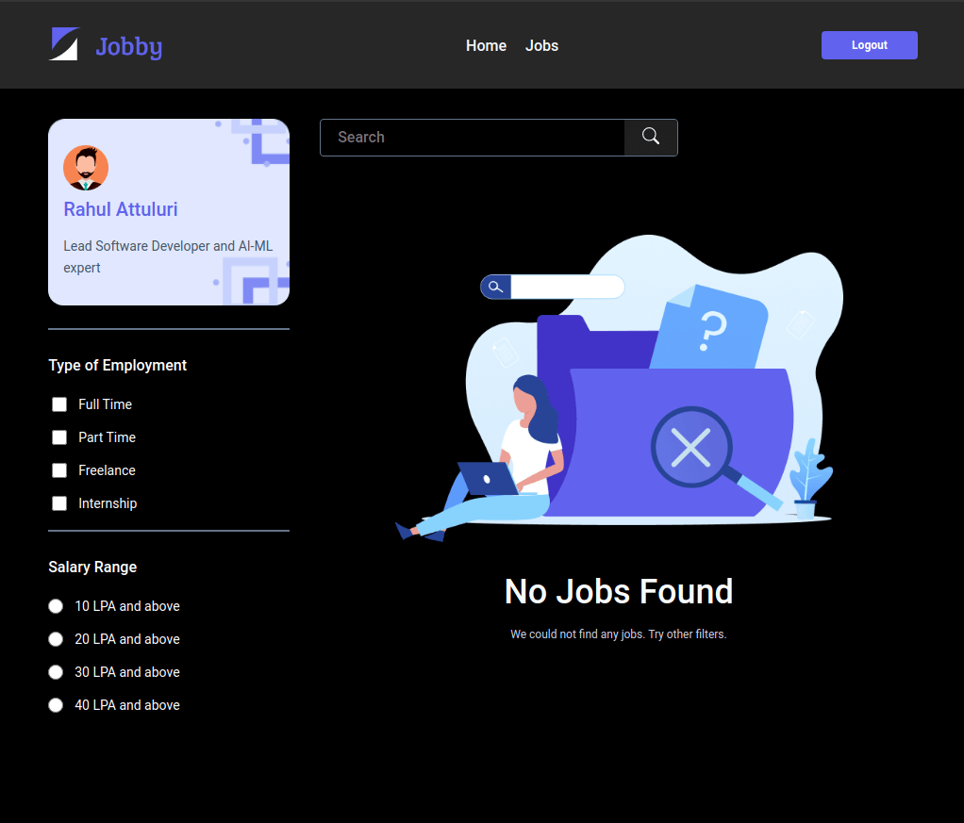

Job Item Details :  
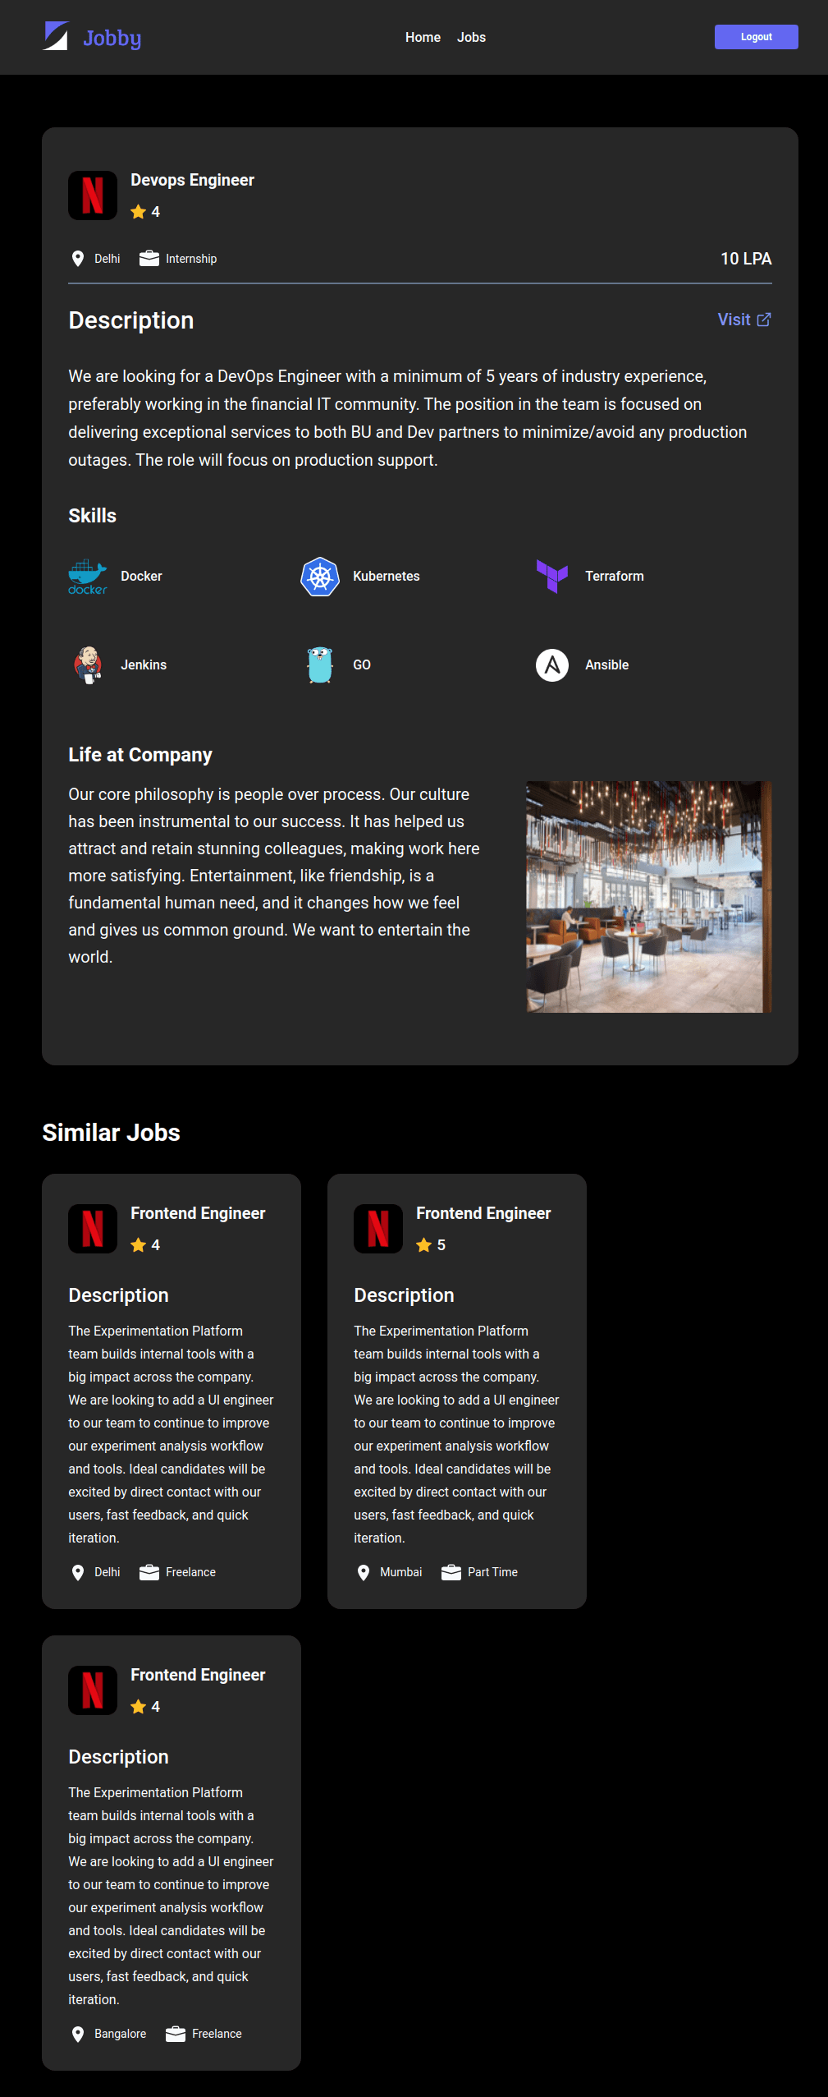

Not Found Route :

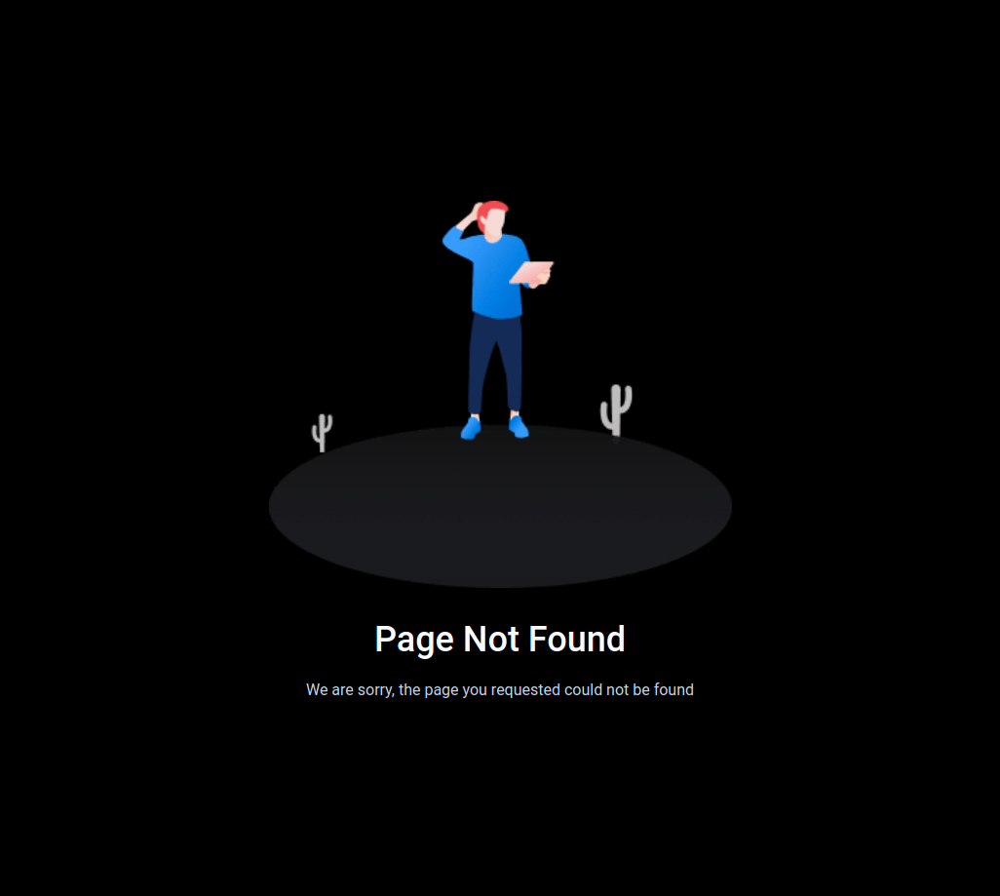

Functionality to be added

The app must have the following functionalities

* Login Route
  + When invalid credentials are provided and the Login button is clicked, then the error message received from the response should be displayed
  + When valid credentials are provided and the Login button is clicked, then the page should be navigated to the Home Route
  + When an *unauthenticated* user, tries to access the Home, Jobs and Job Item Details Route, then the page should be navigated to Login Route
  + When an *authenticated* user, tries to access the Home, Jobs and Job Item Details Route, then the page should be navigated to the respective route
  + When an *authenticated* user, tries to access the Login Route, then the page should be navigated to the Home Route
* Home Route
  + When an *authenticated* user opens the Home Route
    - Clicks on the Find Jobs button, then the page should be navigated to the Jobs Route
* Jobs Route
  + When an *authenticated* user opens the Jobs Route
    - An HTTP GET request should be made to Profile API URL
      * *loader* should be displayed while fetching the data
      * After the data is fetched successfully, the response received should be displayed
      * If the HTTP GET request made is unsuccessful, then the Failure View should be displayed
        + When the Retry button is clicked, an HTTP GET request should be made to Profile API URL
    - An HTTP GET request should be made to Jobs API URL with

employment_type

,

minimum_package

, and

search

 as query parameters with empty strings as initial values

* + - * *loader* should be displayed while fetching the data
      * After the data is fetched successfully, display the list of jobs received from the response
      * If the HTTP GET request made is unsuccessful, then the Failure View should be displayed
        + When the Retry button is clicked, an HTTP GET request should be made to Jobs API URL
    - When a value is provided in the search input and search icon button is clicked
      * Make an HTTP GET request to the Jobs API URL with

jwt_token

 in the Cookies and query parameter

search

 with value as the text provided in the search input

* + - * *loader* should be displayed while fetching the data
      * After the data is fetched successfully, display the list of jobs received from the response
    - When Employment Types options are selected
      * Make an HTTP GET request to the Jobs API URL with

jwt_token

 in the Cookies and query parameter

employment_type

 with value as a list of selected employment type id's as a single string separated by

,

* + - * *loader* should be displayed while fetching the data
      * After the data is fetched successfully, display the list of jobs received from the response
    - When Salary Range is selected
      * Make an HTTP GET request to the Jobs API URL with

jwt_token

 in the Cookies and query parameter

minimum_package

 with value as the id of the selected salary range

* + - * *loader* should be displayed while fetching the data
      * After the data is fetched successfully, display the list of jobs received from the response
    - When the HTTP GET request made to the Jobs API URL returns an empty list for jobs then No Jobs View should be displayed
  + When multiple filters are applied, then the HTTP GET request should be made with all the filters that are applied
  + For example: When the Full Time and Part Time employment types are selected, salary range 10 LPA and above is selected and search input field is empty, then the Jobs API URL will be as follows
  + When a job is clicked, then the page should be navigated to the Job Item Details Route
* Job Item Details Route
  + When an *authenticated* user opens the Job Item Details Route
    - An HTTP GET request should be made to Job Details API URL with

jwt_token

 in the Cookies and job

id

 as path parameter

* + - * *loader* should be displayed while fetching the data
      * After the data is fetched successfully, the response received should be displayed
      * The list of similar jobs should be displayed
      * If the HTTP GET request made is unsuccessful, then the Failure View should be displayed
        + When the Retry button is clicked, an HTTP GET request should be made to Job Details API URL
  + When the Visit button is clicked, then the corresponding company website URL should be opened in a new tab
* Not Found Route
  + When a random path is provided as the URL path, then the page should be navigated to the Not Found Route
* Header
  + When the website logo image is clicked, then the page should be navigated to the Home Route
  + When the Home link is clicked, then the page should be navigated to the Home Route
  + When the Jobs link is clicked, then the page should be navigated to the Jobs Route
  + When the Logout button is clicked, then the page should be navigated to the Login Route
* The App is provided with

employmentTypesList

. It consists of a list of employment type objects with the following properties in each employment type object

| Key | Data Type |
| --- | --- |
| employmentTypeId | String |
| label | String |

* The App is provided with

salaryRangesList

. It consists of a list of salary range objects with the following properties in each salary range object

| Key | Data Type |
| --- | --- |
| salaryRangeId | String |
| label | String |

* Render Home Route component when the path in URL matches /
* Render Login Route component when the path in URL matches /login
* Render Jobs Route component when the path in URL matches /jobs
* Render Job Item Details Route component when the path in URL matches /jobs/:id
* Render Not Found Route component when the path in URL matches /not-found

Image URLs

* https://assets.ccbp.in/frontend/react-js/home-sm-bg.png
* https://assets.ccbp.in/frontend/react-js/home-lg-bg.png
* https://assets.ccbp.in/frontend/react-js/profile-bg.png
* https://assets.ccbp.in/frontend/react-js/logo-img.png alt should be website logo
* https://assets.ccbp.in/frontend/react-js/failure-img.png alt should be failure view
* https://assets.ccbp.in/frontend/react-js/no-jobs-img.png alt should be no jobs
* https://assets.ccbp.in/frontend/react-js/jobby-app-not-found-img.png alt should be not found

Colors

Hex: #64748b

Hex: #4f46e5

Hex: #f8fafc

Hex: #272727

Hex: #ffffff

Hex: #b6c5ff

Hex: #6366f1

Hex: #2c364c

Hex: #000000

Hex: #f1f5f9

Hex: #fbbf24

Hex: #202020

Hex: #cbd5e1

Hex: #7e858e

Hex: #121212

Hex: #475569

Hex: #ff0b37

Font-families

* Roboto